V.V.Sangha's
Veerashaiva College, Ballari
Department of Computer Science
Staff working in the Department : Computer Science
Sl.No | Photo | Name | Qualification | Designation | Date of Joining | Total Length of Servce
1 | 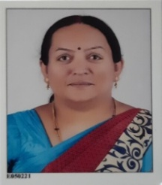 | Smt. Shilpa Patil | M.sc,M.phil | Guest Faculty | 7/6/2003 | 19 Years
2 | 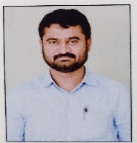 | Sharan Kumar SR | MCA | Guest Faculty | 7/1/2008 | 14 Years
3 | 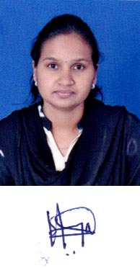 | Kavya K.S | M.Sc,B.E.d | Guest Faculty | 7/1/2015 | 7 years
4 |  | Sunita S.Gouda | MCA | Guest Faculty | 7/1/2015 | 3 years
5 |  | Marisiddana Gouda.M | B.E ,M.Tech | Guest Faculty | 8/1/2016 | 6 years
6 | 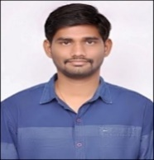 | Santhosh Kumar K | M.Sc | Guest Faculty | 2/1/2018 | 04years
7 |  | Sanjana BM | B.E ,M.Tech | Guest Faculty | 7/1/2019 | 03 YEARS
8 | 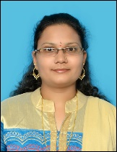 | Sumana CM | B.E ,M.Tech | Guest Faculty | 12/15/2020 | 03 YEARS
9 | 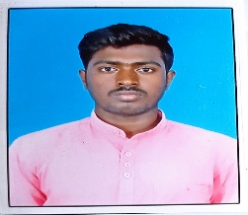 | Vinod Kumar K | M.Sc | Guest Faculty | 1/1/2021 | 01 YEARS
 | 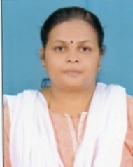 | shoba y | MCA | Guest Faculty | 1/1/2018 | 05 years
 | 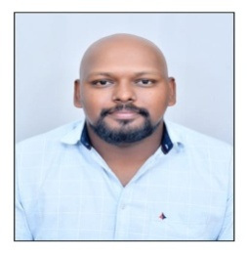 | Nikhila Kumar Y s | MCA | Guest Faculty | 11/15/2022 | 6months
 | 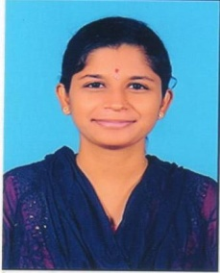 | Greeshma Priya K | M.Sc | Guest Faculty | 6/12/2023 | 1months
 | 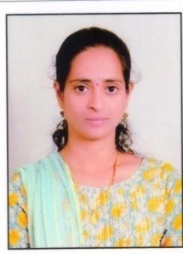 | Rekha N | M.Sc | Guest Faculty | 6/12/2023 | 1months

